Hiring Process Analytics

Arcot Navya Sai ([navyasaipatnaik@gmail.com](mailto:navyasaipatnaik@gmail.com)) +918074851394

**Project Description:** In the given Project we are going to Analyze the Hiring Process. Here we have the dataset where there are 6 Columns namely application_id, Interview Taken on, Status, event_name, Department, Post name, Offered Salary. We are going to perform the analysis using the Microsoft Excel. For better understanding the parameters of hiring process we have used multiple Visuals using different graphs.

**Approach:** We are going to using Multiple Excel Functions, Excel Tables, Pivot Tables, Pivot Charts in our Project to conclude to the Insights. First I have understood the dataset by clearly looking at the Columns and the Values. Then converting the range into Table I have used many functions to get the results I want. To summarize the data, I have used Pivot tables and Pivot charts.

**Tech-Stack Used:** I have used

1. Microsoft Excel (Microsoft Office Professional Plus 2016)
2. Microsoft Word (Microsoft Office Professional Plus 2016)

**Insights:**

**To Identify the outliers, I have used formulas and removed the outliers as True**

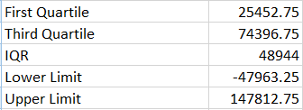

1. **Hiring:** Process of intaking of people into an organization for different kinds of positions.

**(**How many males and females are Hired?**)**



Is the formula I have used

I got the output

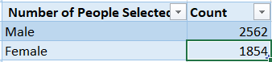

1. **Average Salary:**What is the average salary offered in this company?

Formulas I have used







Output I got is

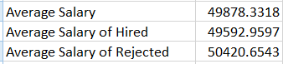

1. **Class Intervals:** Draw the class intervals for salary in the company?

The output I got from Pivot Table

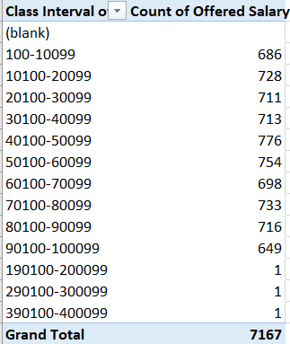

I have also Plotted the Graph

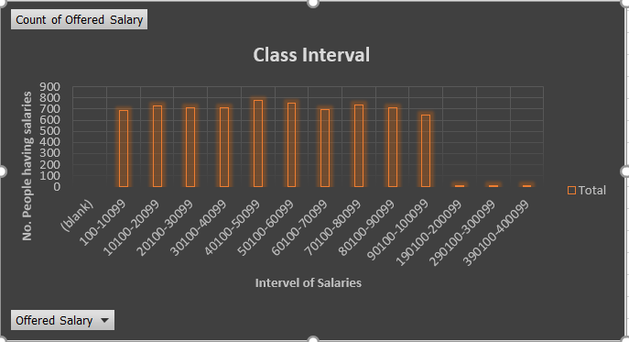

1. **Charts and Plots:** Draw Pie Chart / Bar Graph (or any other graph) to show proportion of people working different department?

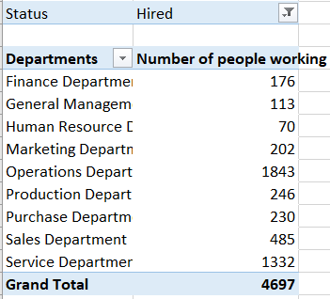

The Pie is obtained from the above Table

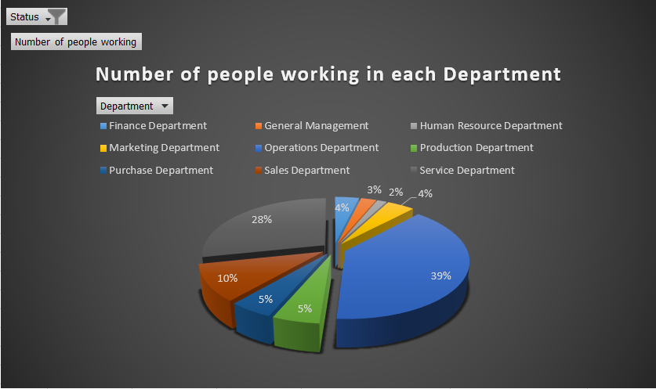

1. **Charts:**Use different charts and graphs to perform the task representing the data.

Number of jobs for Males and Females Who Are Hired and RejectedThe Table is obtained by Pivot Tables

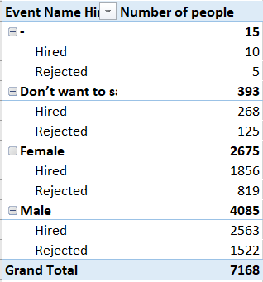

The Graph is obtained from the Pivot Table

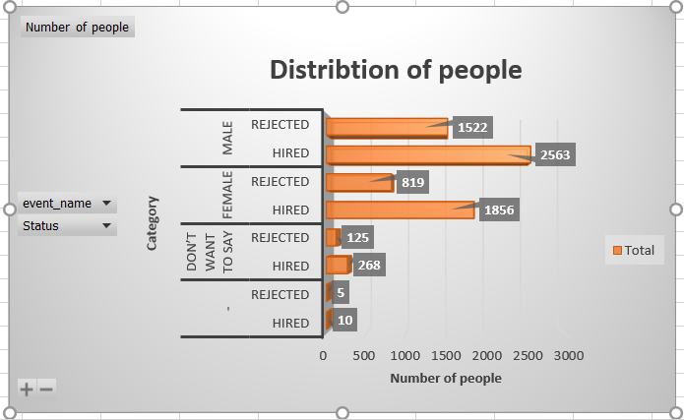

In What Months the Interviews were taken

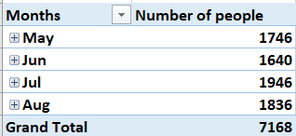

The Graphs Obtained from the above Table

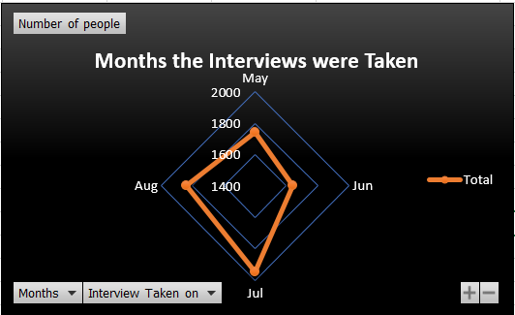

Different Posts for different people

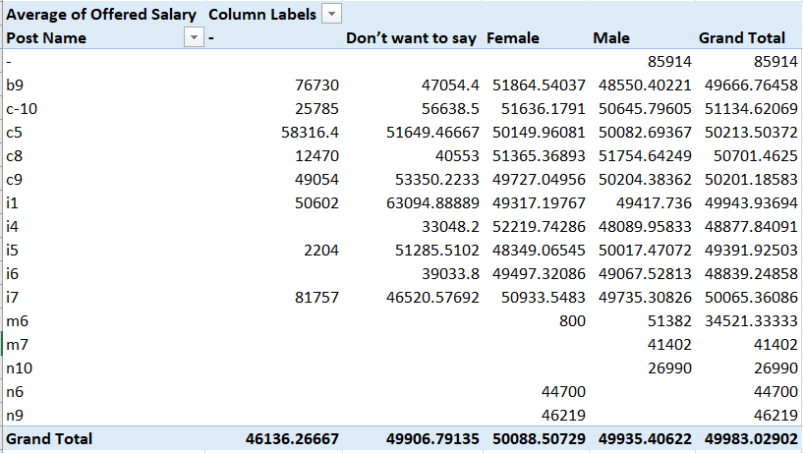

Graph is given from above table

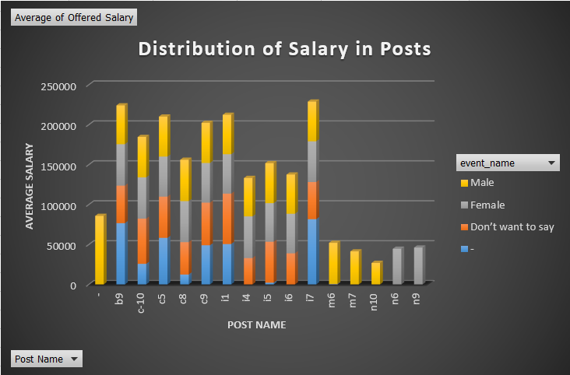

Next I have Taken the number of vacancies in different departments and the Frequencies of Salary class intervals

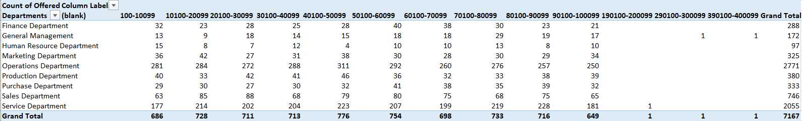

The graph is taken from the above table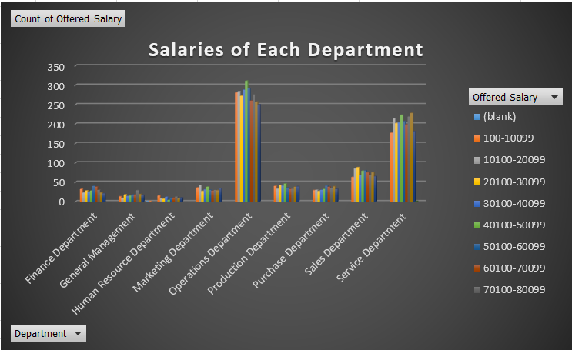

**Result**: I have learned many Excel functionality and Applied in the project that we have solved today. Summarizing the data was the best part as we have understood the Insights better using Visuals and Graphs along with pie charts.

**Drive Link:** [**https://docs.google.com/spreadsheets/d/12QJRK724bQ0GzfkpCG_bZz9A2aV8ONTR/edit?usp=sharing&ouid=106627214281497905501&rtpof=true&sd=true**](Project%204%20Trainity.docx)